Practical Assessment AT2

30003389 – Kyer Potts

# Task One (Debug Code)

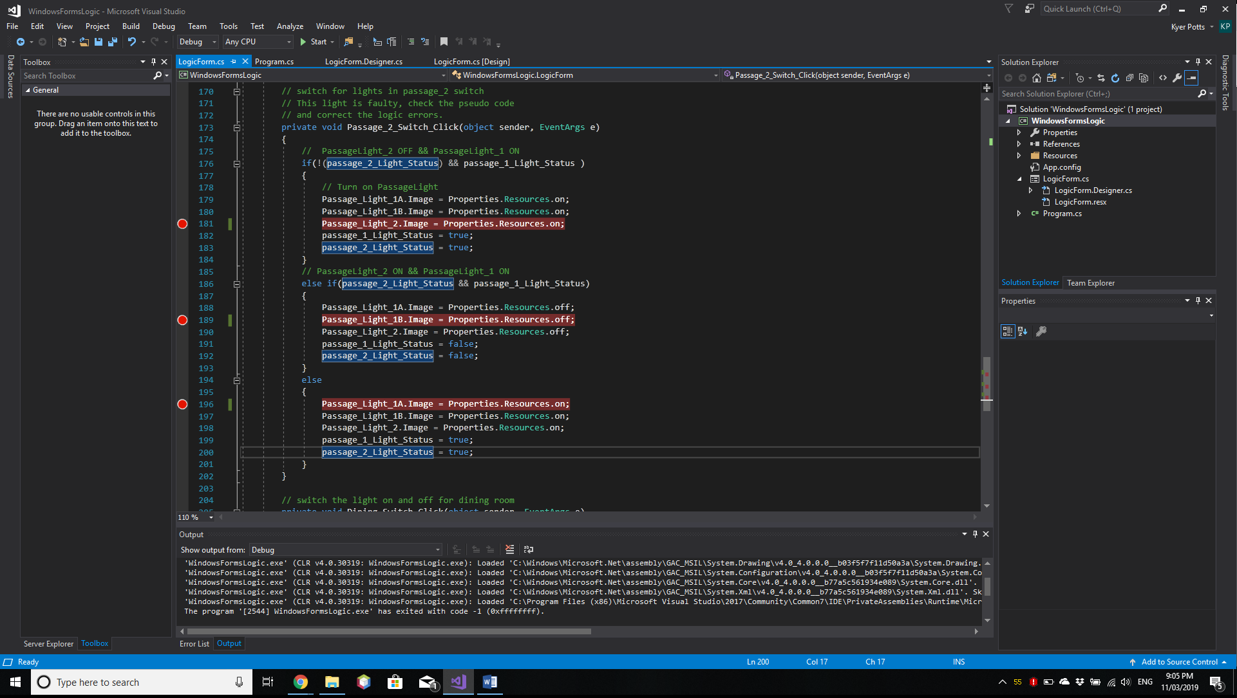

# Task Three

##### Question One

De Morgans Laws are a set of Boolean algebraic rules that allow the expression of conjunction and disjunction in relation to each other by method of negation.

(!(passage_2_Light_Status) && !(passage_1_Light_Status ))

Is equal to

(!(passage_2_Light_Status || passage_1_Light_Status))

##### Question Two

##### C# code: If (bedroom_1_Light_Status OR bath_1_Light_Status)

##### Logic (A || B)

|  |  |  |
| --- | --- | --- |
| ABedroom_1_Light_Status | BBath_1_Light_Status | A or B |
| T | T | T |
| T | F | T |
| F | T | T |
| F | F | F |

##### Question Three

##### C# code: If (!(passage_2_Light_Status) && passage_1_Light_Status)

##### Logic: ((!A) && B)

|  |  |  |  |
| --- | --- | --- | --- |
| APassage_2_Light_Status | NOT A!(Passage_2_Light_Status) | BPassage_1_Light_Status | !A and B |
| T | F | T | F |
| T | F | F | F |
| F | T | T | T |
| F | T | F | F |

##### C# code: Else IF (passage_2_Light_Status && passage_1_Light_Status)

##### Logic: (A && B)

|  |  |  |
| --- | --- | --- |
| APassage_2_Light_Status | BPassage_1_Light_Status | A and B |
| T | T | T |
| T | F | F |
| F | T | F |
| F | F | F |

##### Question Four

##### C# code: If(dining_Light_Status OR entrance_Light_Status)

##### Logic: (A || B || C)

|  |  |  |  |
| --- | --- | --- | --- |
| ADining_Light_Status | BLounge_Light_Status | CEntrance_Light_Status | A or B or C |
| T | T | T | T |
| F | T | T | T |
| F | F | T | T |
| F | F | F | F |
| T | F | F | T |
| T | T | F | T |
| T | F | T | T |
| F | T | F | T |